**BookInGo**

**(Library Management System)**

**A PROJECT REPORT**

***Submitted by***

**YASH SHARMA**

**2115001158**

***in partial fulfillment for the award of the degree of***

**B.TECH**

**IN**

Computer Science Engineering

November 2023

**GLA University, Mathura**

November 2022

**BONAFIDE CERTIFICATE**

Certified that this project report **BookInGo(Library Management System)** is the bonafide work of Yash Sharmawho carried out the project work under my

|  |  |
| --- | --- |
| Supervision. | Mr Abhishek Kr. Tiwari |
| **SIGNATURE**    Dr. Rohit Agrawal    **HEAD OF THE DEPARTMENT**    Department of Computer Science & Engineering | **SIGNATURE**    Abhishek Kr. Tiwari  **SUPERVISOR**  Master Trainer    Training and Placement Dept. |

Submitted for the project viva-voce examination held on November 2023

**INTERNAL EXAMINER EXTERNAL EXAMINER**

**TABLE OF CONTENTS**

Abstract............................................................................................................ i

**Chapter 1. INTRODUCTION...................................................................**

1.1.Objectives.............................................................................................01

1.2 Project Aims and Goals........................................................................01

1.3 Background of Project..........................................................................02

**Chapter 2. LITERATURE REVIEW..................................................**

2.1.Timeline of the reported problem...................................................03

2.2.Proposed Solutions.........................................................................04

2.3.Review Summary............................................................................04

2.4.Problem Definition.........................................................................04

2.5.Functionality...................................................................................04-05

**Chapter 3. DESIGN FLOW/PROCESS**

3.1.Evaluation & Selection of Specifications/Features .......................06

3.2.Design Constraints..........................................................................06-07

3.3.Analysis and Feature finalization subject to constraints..................07-08

3.4.Design Flow ....................................................................................08

3.5.Design Selection......................................................... .....................08-09

**Chapter 4. RESULTS ANALYSIS AND SCREENSHOTS**

4.1.Implementation of solution ............................................................10-11

4.2.Screenshots of Application.............................................................x

**Chapter 5. CONCLUSION AND FUTURE WORK**

5.1.Conclusion.......................................................................................y

5.2.Future Work.......................................................................................z

**References**

**Appendix**

**ABSTRACT**

Library management system is a project which aims in developing a computerized system to maintain all the daily work of library .This project has many features which are generally not available in normal library management systems like facility of user login and a facility of admin login .It also has a facility of admin login through which the admin can monitor the whole system . It has also a facility where student after logging in their accounts can see list of books issued and its issue date and return date. Overall this project of ours is being developed to help the students as well as staff of library to maintain the library in the best way possible and also reduce the human efforts.

**INTRODUCTION**

**1.1. Objectives**

BookInGo has been developed to override the problems prevailing in practice of manual system. This application will eliminate the manual work and hardships faced in real time to make it in a smooth, fast and responsive manner. Basically it will reduce the human efforts and chances of any manual mistakes will be reduced with the help of the application implementation.

**1.2. Project Aims And Goals**

The project aims and objectives that will be achieved after completion of this project are discussed in this subchapter. The aims and objectives are as follows:

* Online book issue
* Request column for librarian for providing new books
* Student login page where student can find books issued by him/her and date of return.
* A search column to search availability of books

**1.3. Background Of Project**

Library Management System is an application which refers to library systems which are generally small or medium in size. It is used by librarian to manage the library using a computerized system where he/she can record various transactions like issue of books, return of books, addition of new books, addition of new students etc. Books and student maintenance modules are also included in this system which would keep track of the students using the library and also a detailed description about the books a library contains. With this computerized system there will be no loss of book record or member record which generally happens when a non computerized system is used. All these modules are able to help librarian to manage the library with more convenience and in a more efficient way as compared to library systems which are not computerized.

**LITERATURE REVIEW/BACKGROUND STUDY**

**2.1. Timeline of the reported problem**

The problem occurred before having computerized system includes:

* File lost, When computerized system is not implemented file is always lost because of human environment.Some times due to some human error there may be a loss of records.
* File damaged, When a computerized system is not there file is always lost due to some accident like spilling of water by some member on file accidentally. Besides some natural disaster like floods or fires may also damage the files
* Difficult to search record, When there is no computerized system there is always a difficulty in searching of records if the records are large in number .
* Space consuming, After the number of records become large the space for physical storage of file and records also increases if no computerized system is implemented.
* Cost consuming, As there is no computerized system the to add each record paper will be needed which will increase the cost for the management of library.

**2.2. Proposed Solutions**

Library Management System is a computerized system which helps user(librarian) to manage the library daily activity in electronic format. It reduces the risk of paper work such as file lost, file damaged and time consuming. It can help user to manage the transaction or record more effectively and time-saving

**2.3. Review Summary**

The LMS is much more user-friendly, faster in operation and easy to manage than the manual one. Problem Statement: The current library system is outdated and inefficient. There is a lack of organization in book management, book borrowing. The main purpose of a library management system is to manage & track the daily work of the library such as issuing books, return books, due calculations, etc.

**2.4. Problem Definition**

The main need for this BookInGo project will help to manage the details of books which are being issued in real time and managing the data correctly becomes a big challenge manually, as maintaining the records of all the books and books being issued to any specific student for a correct time period and returned back at correct time and management of fine, if not done at right time and a proper system to notify students at proper time for their actions.

Hence this application will helps us to reduce this human work and build in a fast and correct system wherein all this can be done appropriately.

**2.5. Functionality**

Presently it will have a data warehouse in form of file where in we will have a stock of all the books available in library so it will works as a database in this case and we will have modification in this data while using this application.

Suppose a new book is added and a student got it issues on his/her name then he/she after sharing his details like email, they will immediately get notified about the book issuing email, consisting details for book name, time period of book issue validity.

And when the validity of book will expire user will again get notified about the same and fine will be added on them and they will be notified for that too.

**DESIGN FLOW/PROCESS**

**3.1. Evaluation & Selection of Specifications/Features**

* Managing the books in real time in library.
* Storing the records of books in library
* Notify the students when they issue a book
* Provide proper details to students in email
* Validation of time period for book validity
* Notification for book expiry and fine, if expiry happens.
* Easy to understand and operate.

**3.2. Design Constraints**

Library procedures and practices for managing the LMS should reflect library ethics, policies, and legal obligations concerning user privacy. Agreements between libraries and vendors should specify the following:

* Libraries retain ownership of all data;
* The vendor will comply with the appropriate federal, state, and local library privacy laws;
* The vendor agrees to observe the library's privacy, data retention, and security policies; and
* Other parties used by the vendor will follow these policies.
* ALA provides these guidelines for libraries using an LMS. The guidelines include information about appropriate data management and security practices for library users' personal data.

**3.3. Analysis and Feature finalization subject to constraints**

A web application which will help to reduce the manual work of maintaing all the necessary details of issued books and fast system with error-less data and a system of generating emails once they perform some actions in library with books like(issue a book, return a book, etc).

* A modern integrated library management system (LMS).
* Can be scalable to Windows, Linux and Mac OS platform.
* Full catalogue, circulation and acquisitions system for library stock management.
* Simple, clear search interface for all users
* Export and import records
* Easy way to enter new books
* Keep record of complete info of a book like title, author name, publisher name etc.
* Easy way to check-in and check-out
* It is user-friendly software
* Keep record of different categories
* Classify the books subject wise

**3.4. Design Flow**

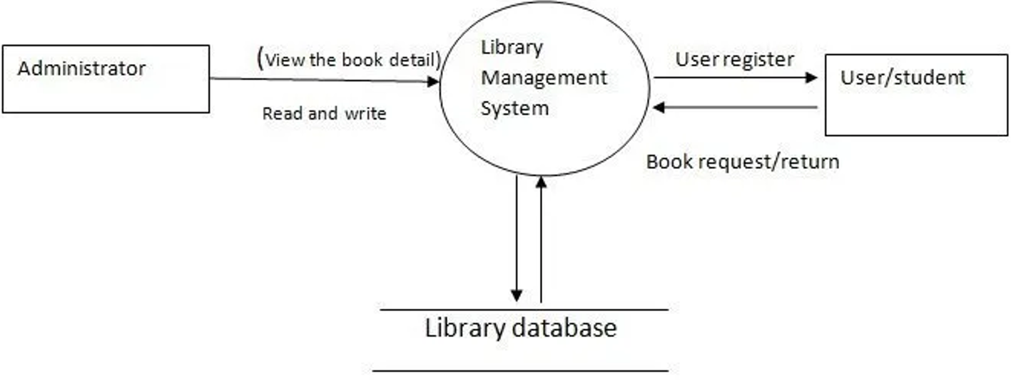

**3.5. Design Selection**

In software engineering, a software design pattern is a general, reusable solution to a commonly occurring problem within a given context in software design. It is not a finished design that can be transformed directly into source or machine code. Rather, it is a description or template for how to solve a problem that can be used in many different situations. Design patterns are formalized best practices that the programmer can use to solve common problems when designing an application or system. Object-oriented design patterns typically show relationships and interactions between classes or objects, without specifying the final application classes or objects that are involved. Patterns that imply mutable state may be unsuited for functional programming languages. Some patterns can be rendered unnecessary in languages that have built-in support for solving the problem they are trying to solve, and object-oriented patterns are not necessarily suitable for non-object-oriented languages. Design patterns may be viewed as a structured approach to computer programming intermediate between the levels of a programming paradigm and a concrete algorithm.

**RESULTS ANALYSIS AND SCREENSHOTS**

**4.1. Implementation of Solution**

Technologies and Tools used for implementation:-

**HTML**- HTML or Hyper Text Markup Language is the main markup language for creating web pages and other information that can be displayed in a web browser.HTML is written in the form of HTML elements consisting of tags enclosed in angle brackets (like <html>), within the web page content. HTML tags most commonly come in pairs like <h1> and </h1>, although some tags represent empty elements and so are unpaired, for example <img>. The first tag in a pair is the start tag, and the second tag is the end tag (they are also called opening tags and closing tags). In between these tags web designers can add text, further tags, comments and other types of text-based content. The purpose of a web browser is to read HTML documents and compose them into visible or audible web pages. The browser does not display the HTML tags, but uses the tags to interpret the content of the page.HTML elements form the building blocks of all websites.

HTML allows images and objects to be embedded and can be used to create interactive forms. It provides a means to create structured documents by denoting structural semantics for text such as headings, paragraphs, lists, links, quotes and other items. It can embed scripts written in languages such as JavaScript which affect the behaviour of HTML web pages.

**CSS**- Cascading Style Sheets (CSS) is a style sheet language used for describing the look and formatting of a document written in a markup language. While most often used to style web pages and interfaces written in HTML and XHTML, the language can be applied to any kind of XML document, including plain XML, SVG and XUL. CSS is a cornerstone specification of the web and almost all web pages use CSS style sheets to describe their presentation.CSS is designed primarily to enable the separation of document content from document presentation, including elements such as the layout, colors, and fonts. This separation can improve content accessibility, provide more flexibility and control in the specification

of presentation characteristics, enable multiple pages to share formatting, and reduce complexity and repetition in the structural content (such as by allowing for table less web design).CSS can also allow the same markup page to be presented in different styles for different rendering methods, such as on-screen, in print, by voice (when read out by a speech-based browser or screen reader) and on Braille-based, tactile devices. It can also be used to allow the web page to display differently depending on the screen size or device on which it is being viewed. While the author of a document typically links that document to a CSS file, readers can use a different style sheet, perhaps one on their own computer, to override the one the author has specified. However if the author or the reader did not link the document to a specific style sheet the default style of the browser will be applied.CSS specifies a priority scheme to determine which style rules apply if more than one rule matches against a particular element. In this so-called cascade, priorities or weights are calculated and assigned to rules, so that the results are predictable.

**AppScript** -Google Apps Script is a rapid application development platform that makes it fast and easy to create business applications that integrate with Google Workspace. You write code in modern JavaScript and have access to built-in libraries for favourite Google Workspace applications like Gmail, Calendar, Drive, and more. There's nothing to install—we give you a code editor right in your browser, and your scripts run on Google's servers.

**4.2. Screenshots of application**

Inserting Book

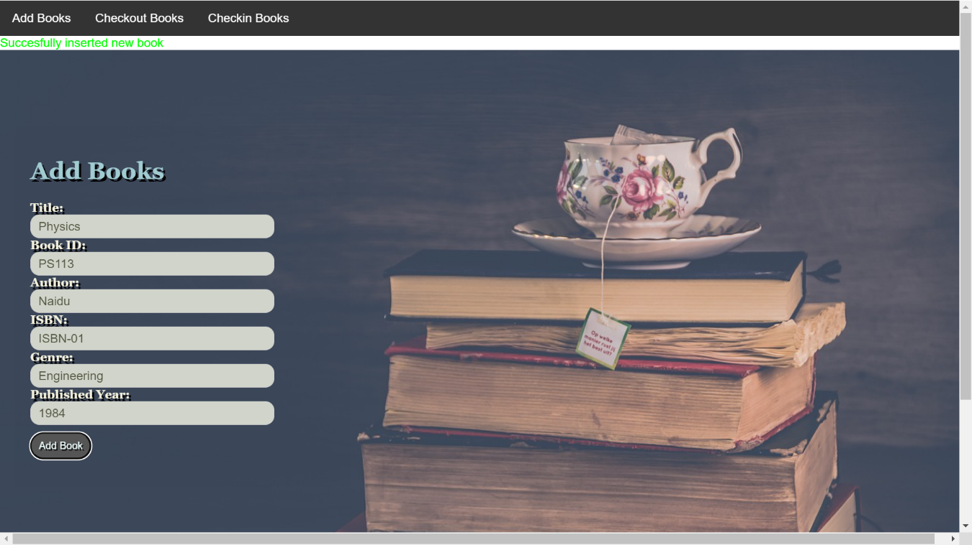

Check Out Book

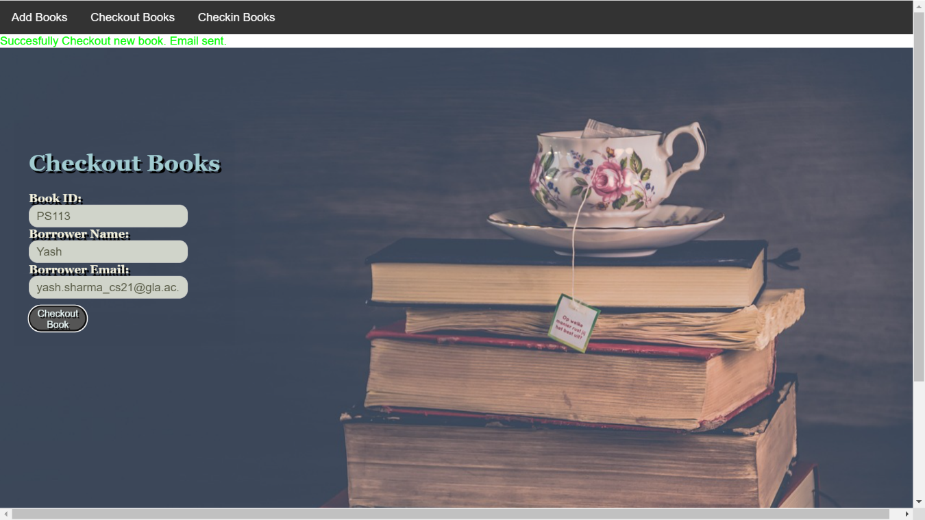

Book Already Checked Out:

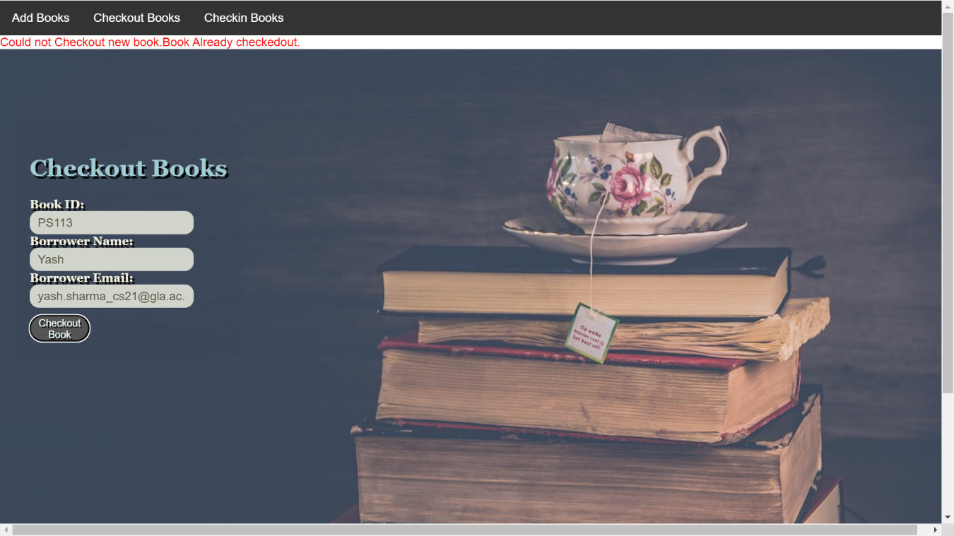

Checkout updated in Google Sheet:

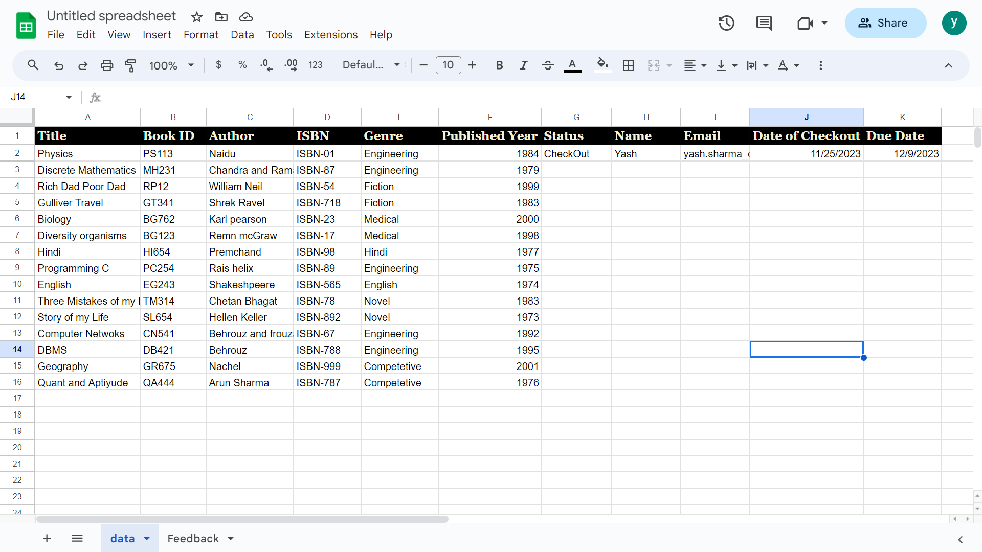

Book not found for checkout:

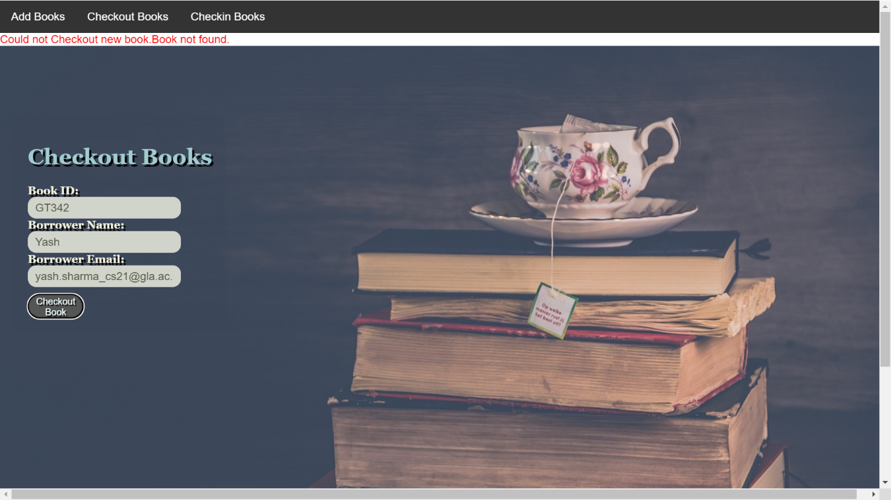

Check In Book:

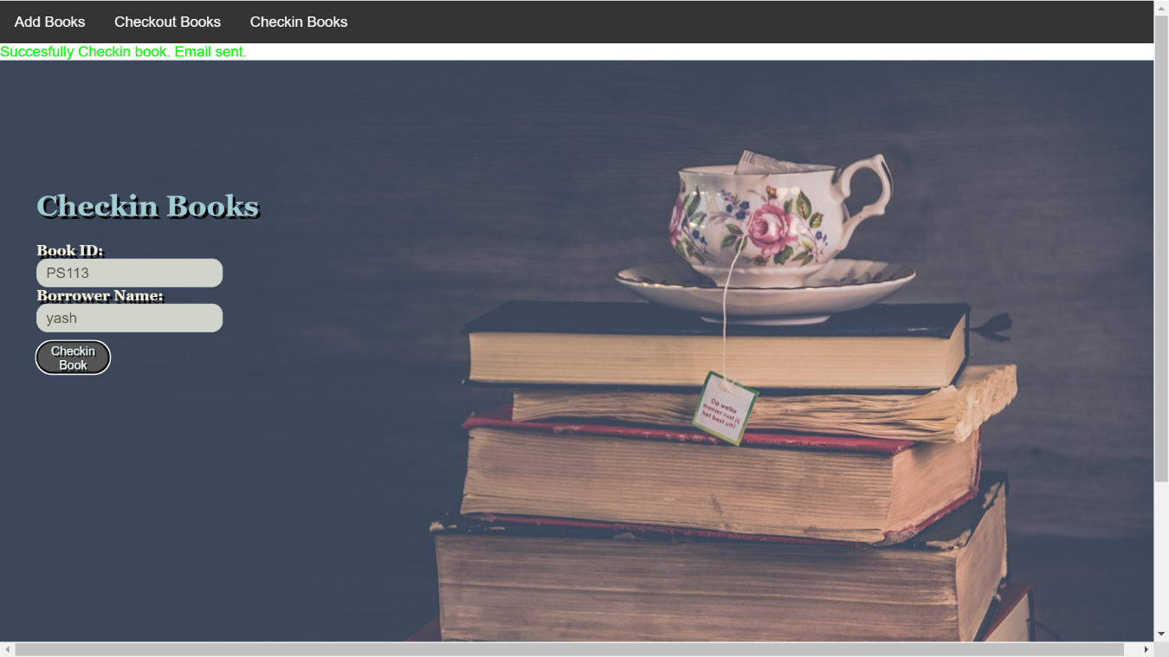

Book already CheckedIn:

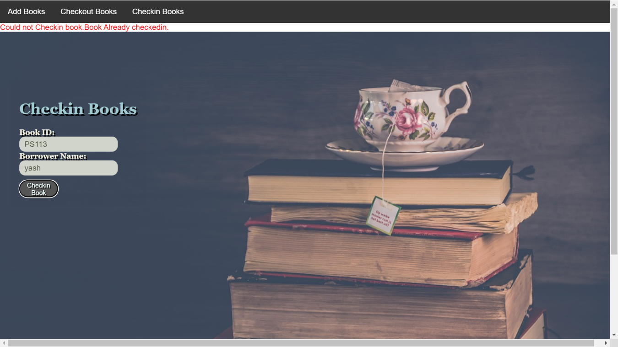

Book not found for CheckIn:

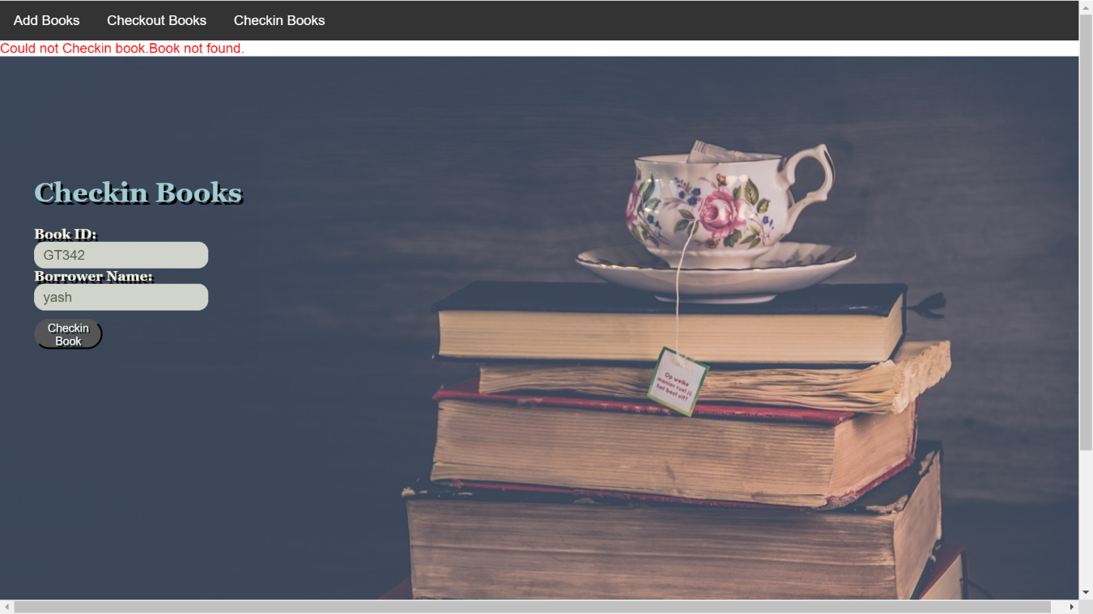

Checkout notification Email:

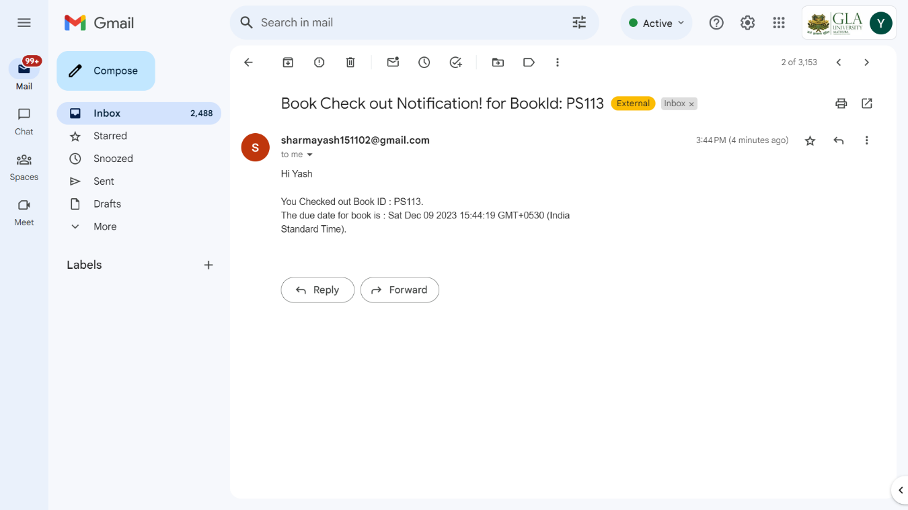

Email CheckIn Notification:

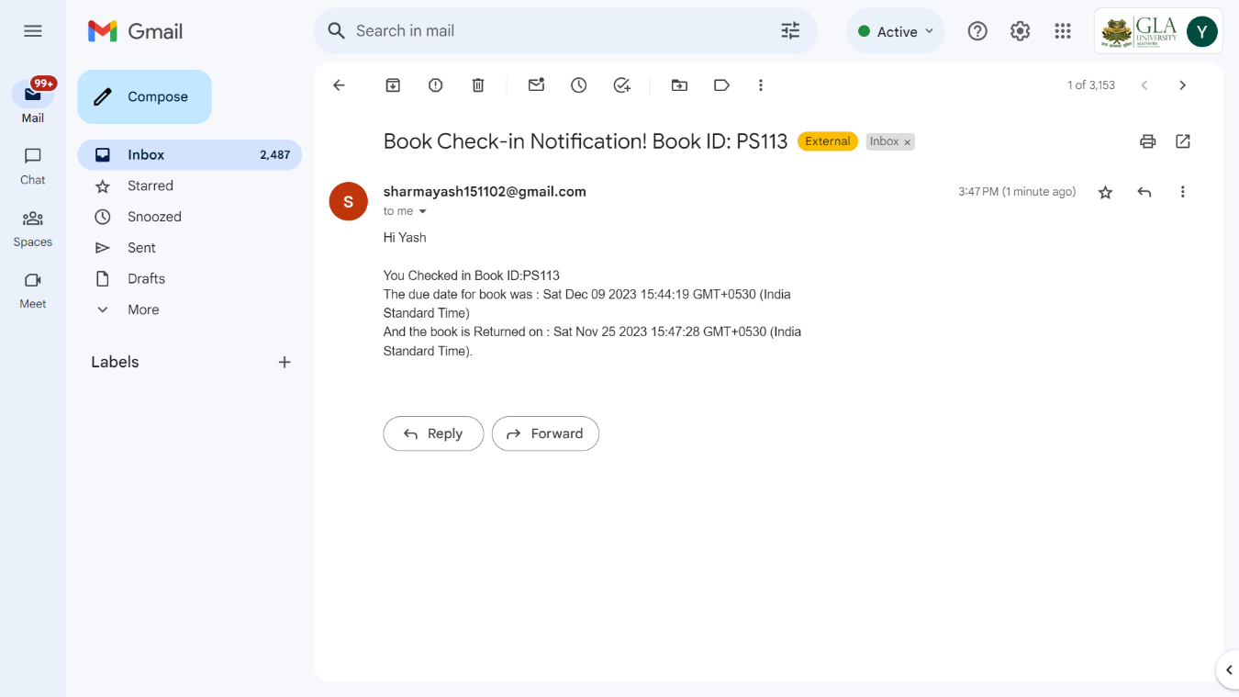

Email CheckIn Notification with Fine calculation:

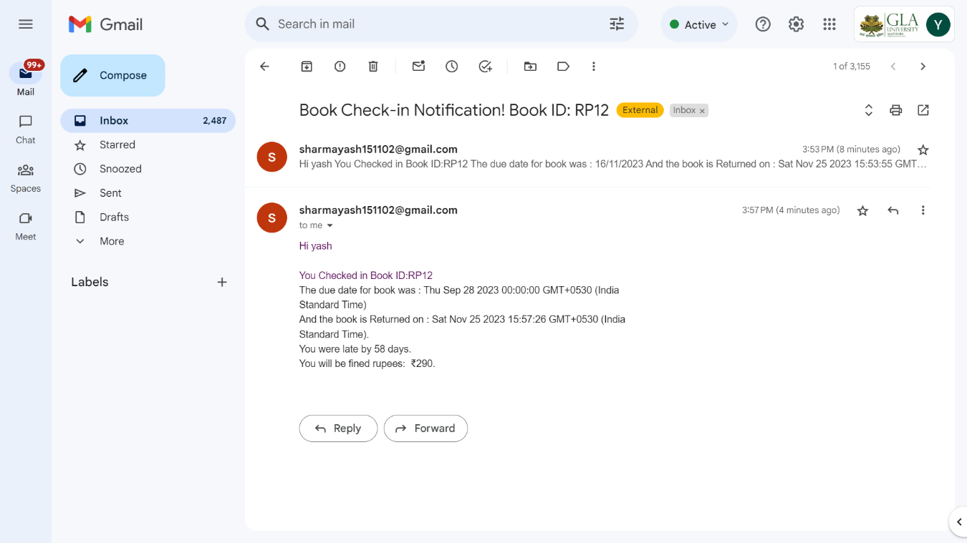

Feedback Display page:

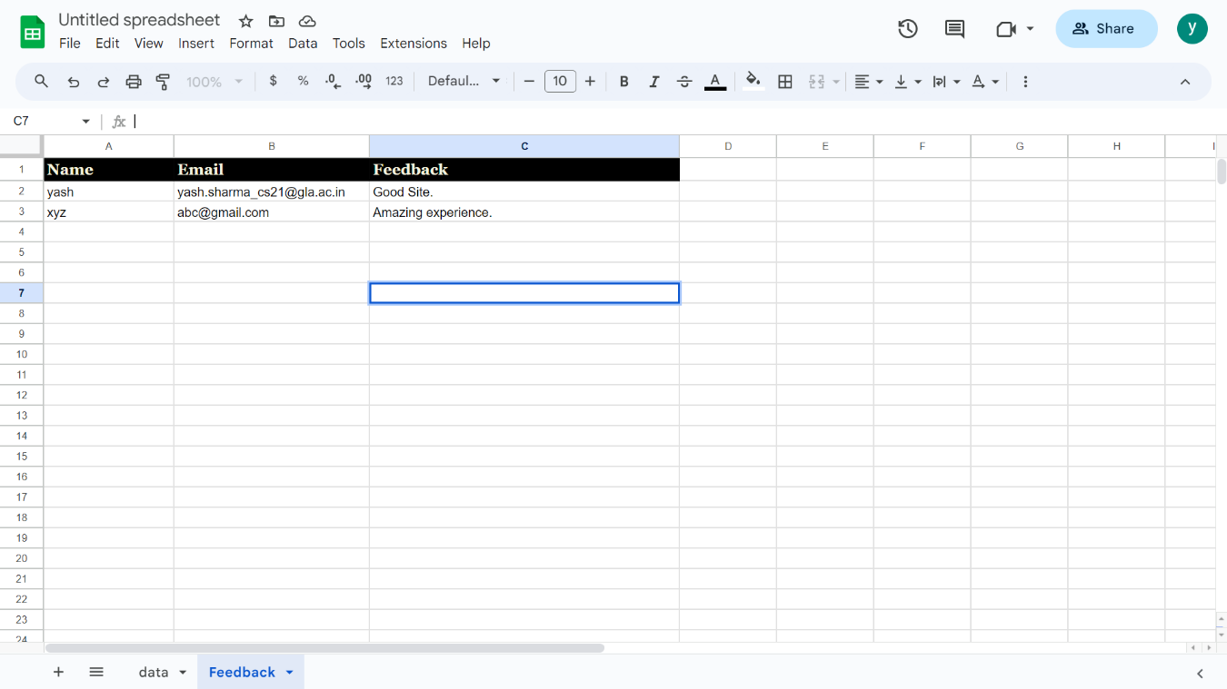

Feedback Sent popup:

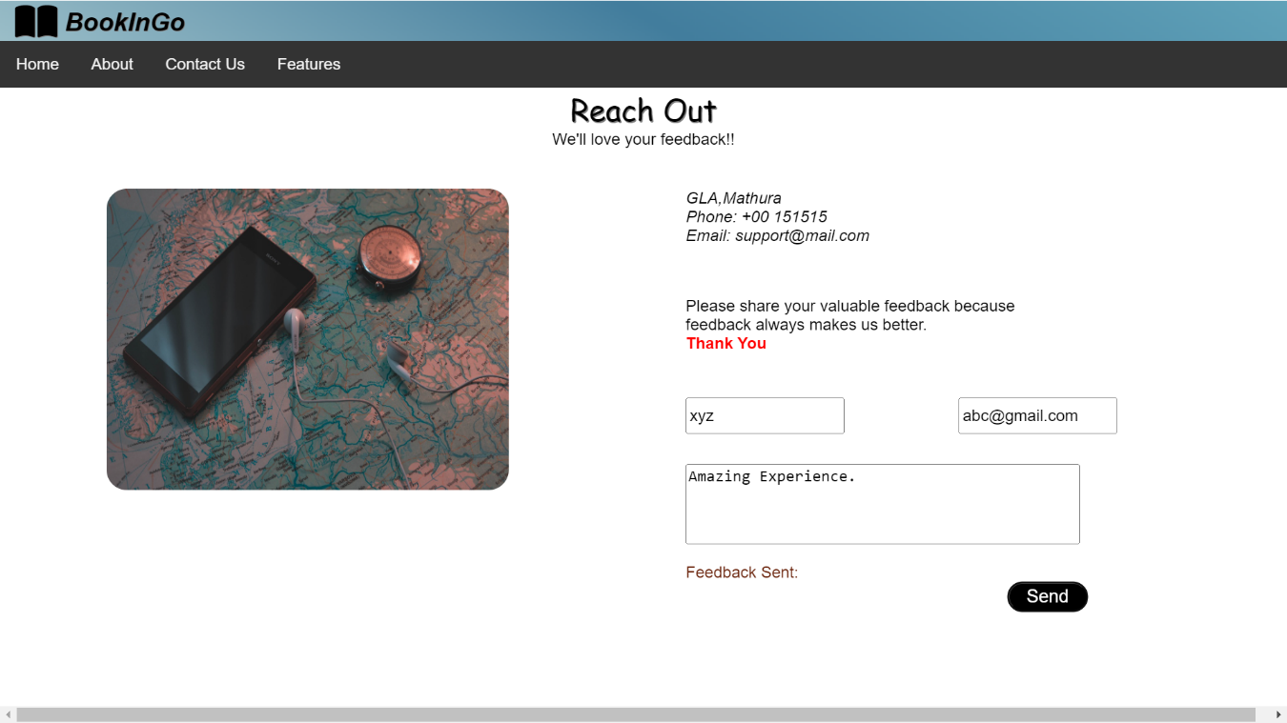

**CONCLUSION AND FUTURE WORK**

**5.1. Conclusion**

This website provides a computerized version of library management system which will benefit the students as well as the staff of the library. It makes entire process online where student can search books, staff can generate reports and do book transactions. It also has a facility for student login where student can login and can see status of books issued as well request for book or give some suggestions. It has a facility of teacher’s login where teachers can add lectures notes and also give necessary suggestion to library and also add info about workshops or events happening in our college or nearby college in the online notice board.

**5.2. Future Work**

There is a future scope of this facility that many more features such as online lectures video tutorials can be added by teachers as well as online assignments submission facility , a feature Of group chat where students can discuss various issues of engineering can be added to this project thus making it more interactive more user friendly and project which fulfils each users need in the best way possible .

**REFERENCES**

* [**https://www.w3schools.com/html/**](https://www.w3schools.com/html/)
* [**https://www.w3schools.com/css/default.asp**](https://www.w3schools.com/css/default.asp)
* [**https://www.w3schools.com/js/default.asp**](https://www.w3schools.com/js/default.asp)
* [**https://code.visualstudio.com/docs**](https://code.visualstudio.com/docs)
* [**https://developers.google.com/apps-script**](https://developers.google.com/apps-script)

**APPENDIX**

**User Manual**

Login into the BookInGO application and go to features tab and perform the required action(add book, checkout book, etc)

Navigate to the multiple tabs for more information in the application.